QUESTION 3: EXAM REGISTRATION

CLASS DIAGRAM:

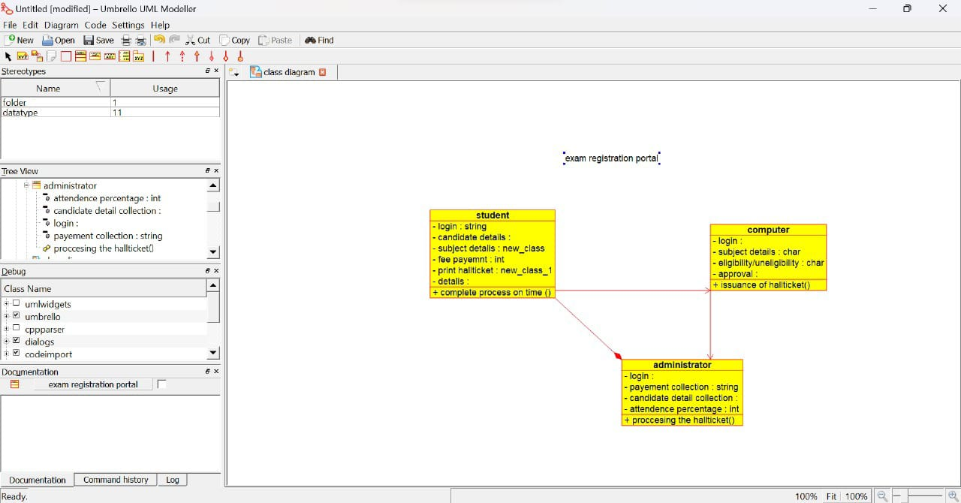

USE CASE DIAGRAM:

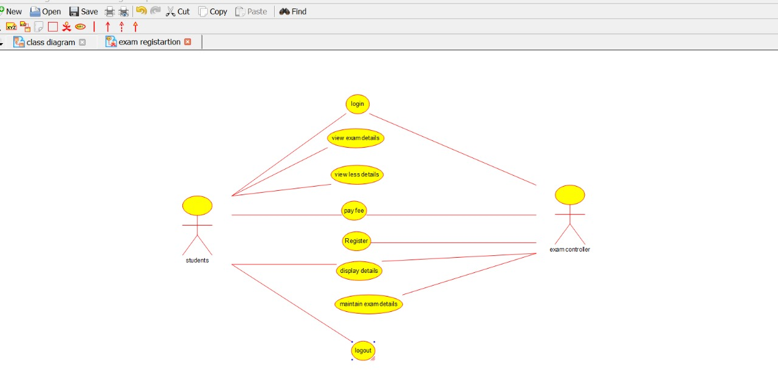

ACTIVITY DIAGRAM:

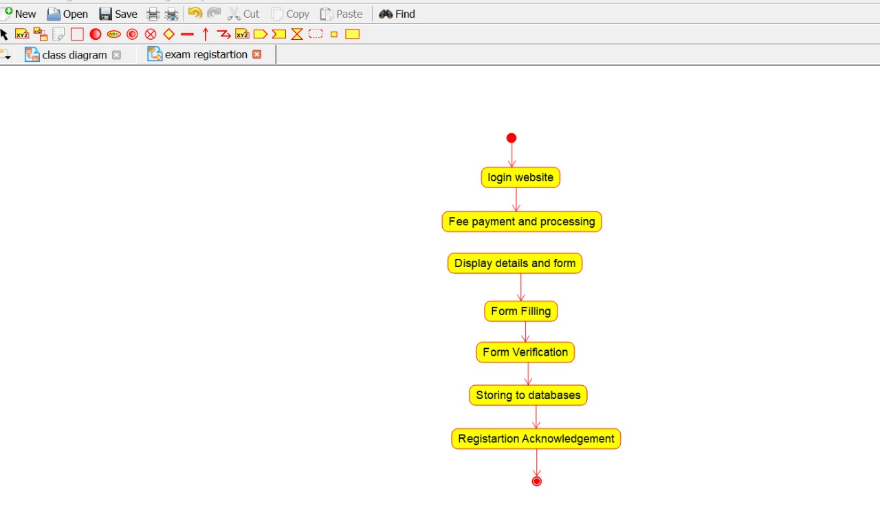

COLLABRATION DIAGRAM:

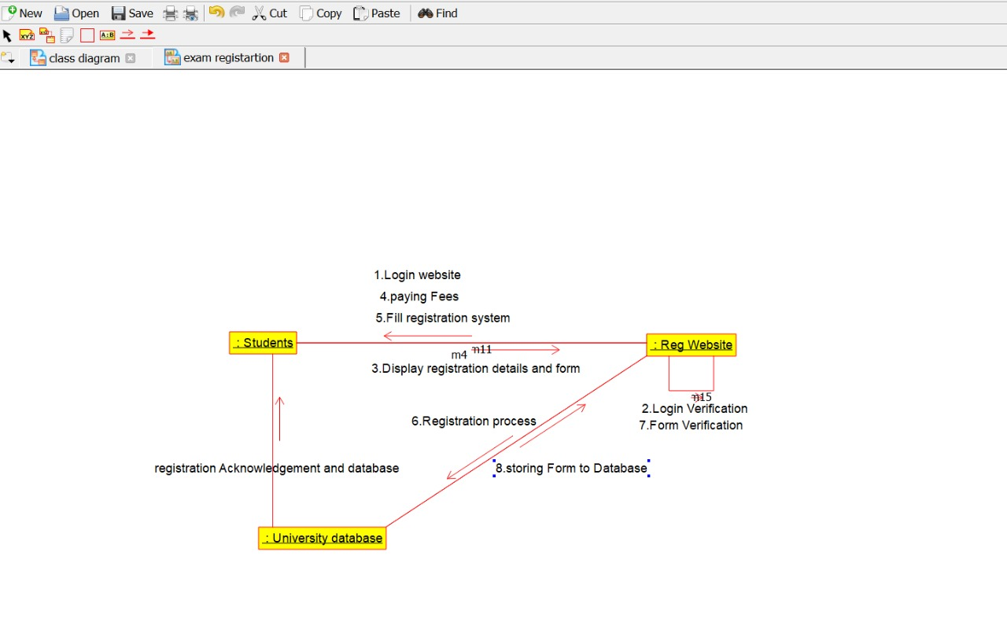

STATE CHART DIAGRAM:

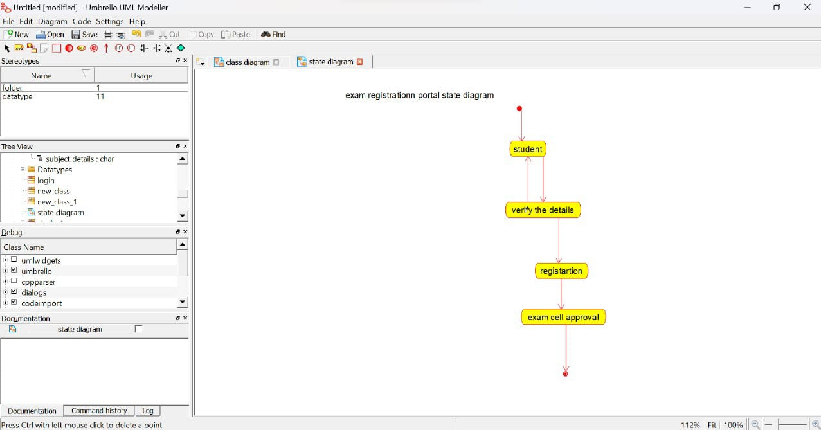

DEPLOYMENT DIAGRAM:

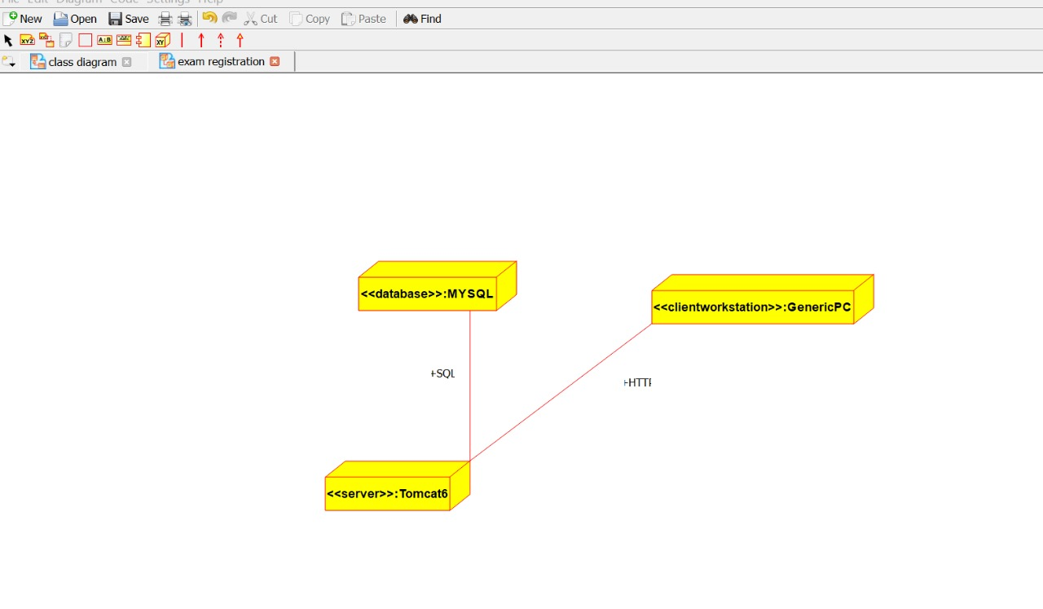

COMPONENT DIAGRAM:

